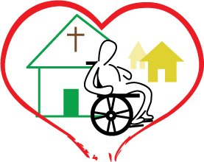
Dominican Republic Disability Ministry
Hogares Lutheranos el Buen Pastor
(Good Shepherd Lutheran Homes)
$ 5,000
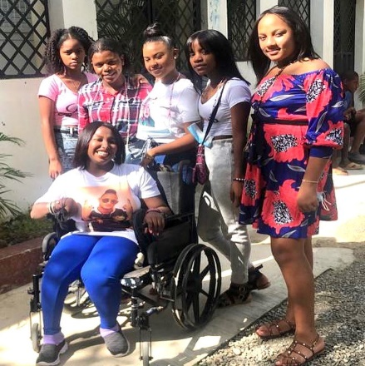
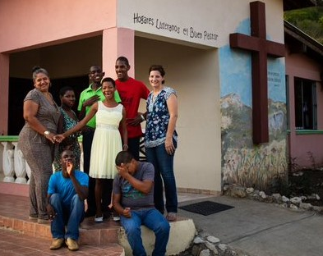
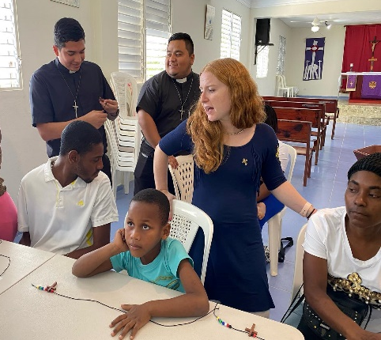

People with intellectual and developmental disabilities in the Dominican Republic generally live very marginalized from the rest of society and the government provides no services to educate or help these people or their families, so they sink further into poverty.

Funds from LWML are essential in helping HLBP raised the needed financial support to care for the youth in the home and continuing caring for and ministering to others outside of the home. No public funding is available from the Dominican government for private homes or institutions that care for people with intellectual and developmental disabilities.

2022-2024 Biennium – LWML Washington-Alaska District

